**Sentiment Based Product Recommendation System (Flask Implementation)**

Lets enter the username to see if it suggests Top 5 products based on user name.

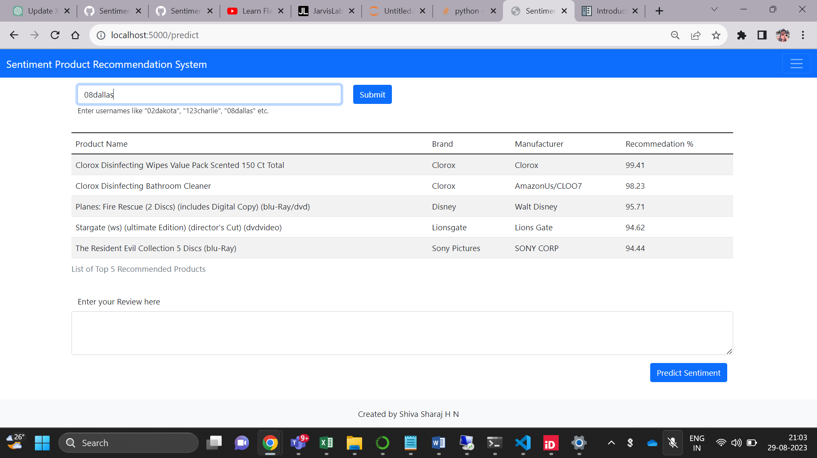

In the below screenshot we can see the recommended products for the user named **08dallas**

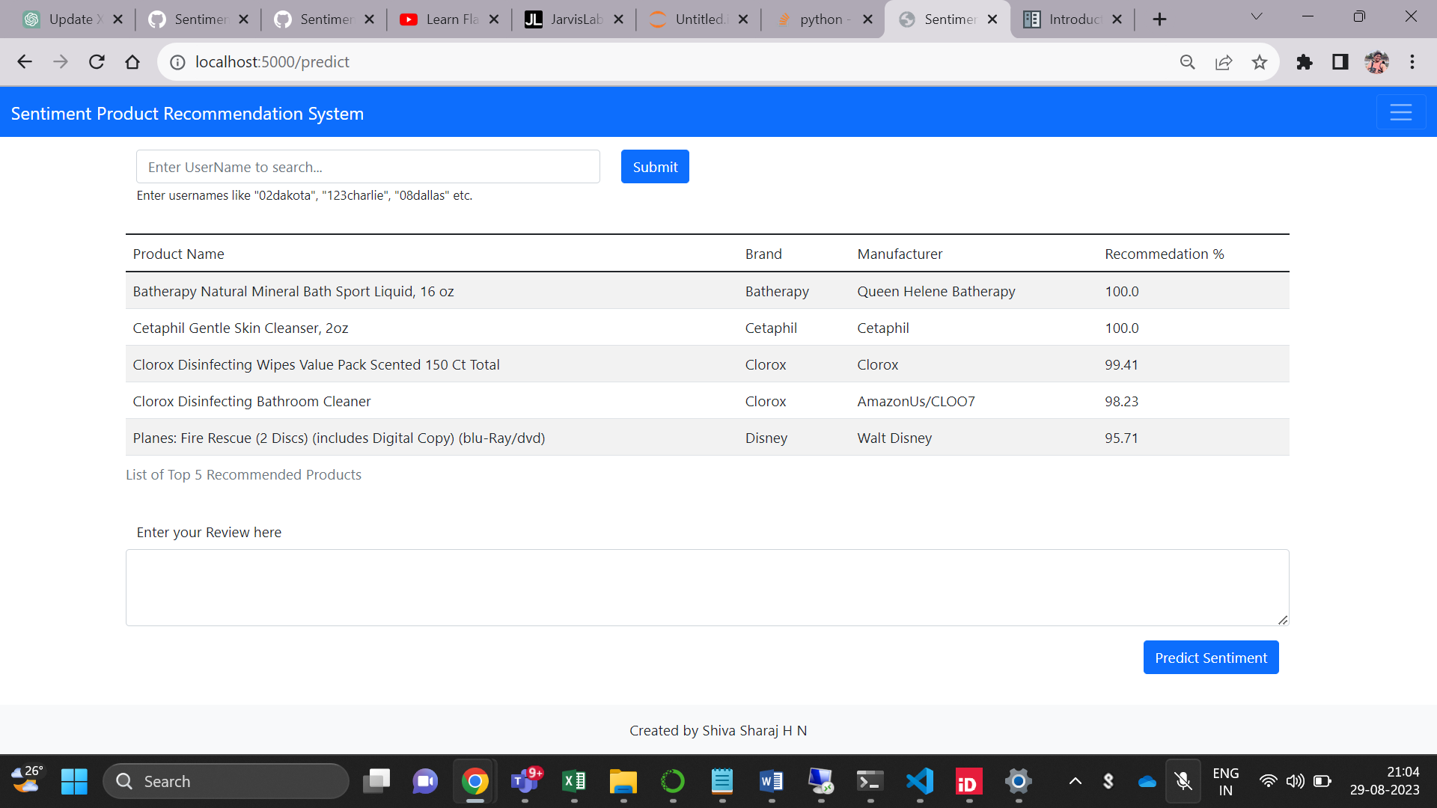

Let’s check if the model Is predicting the positive and negative sentiments appropriately. 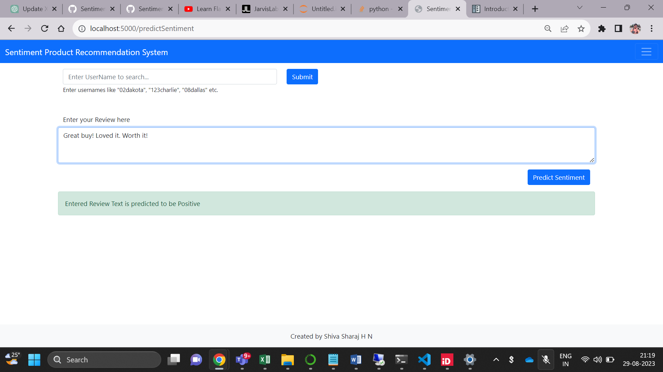

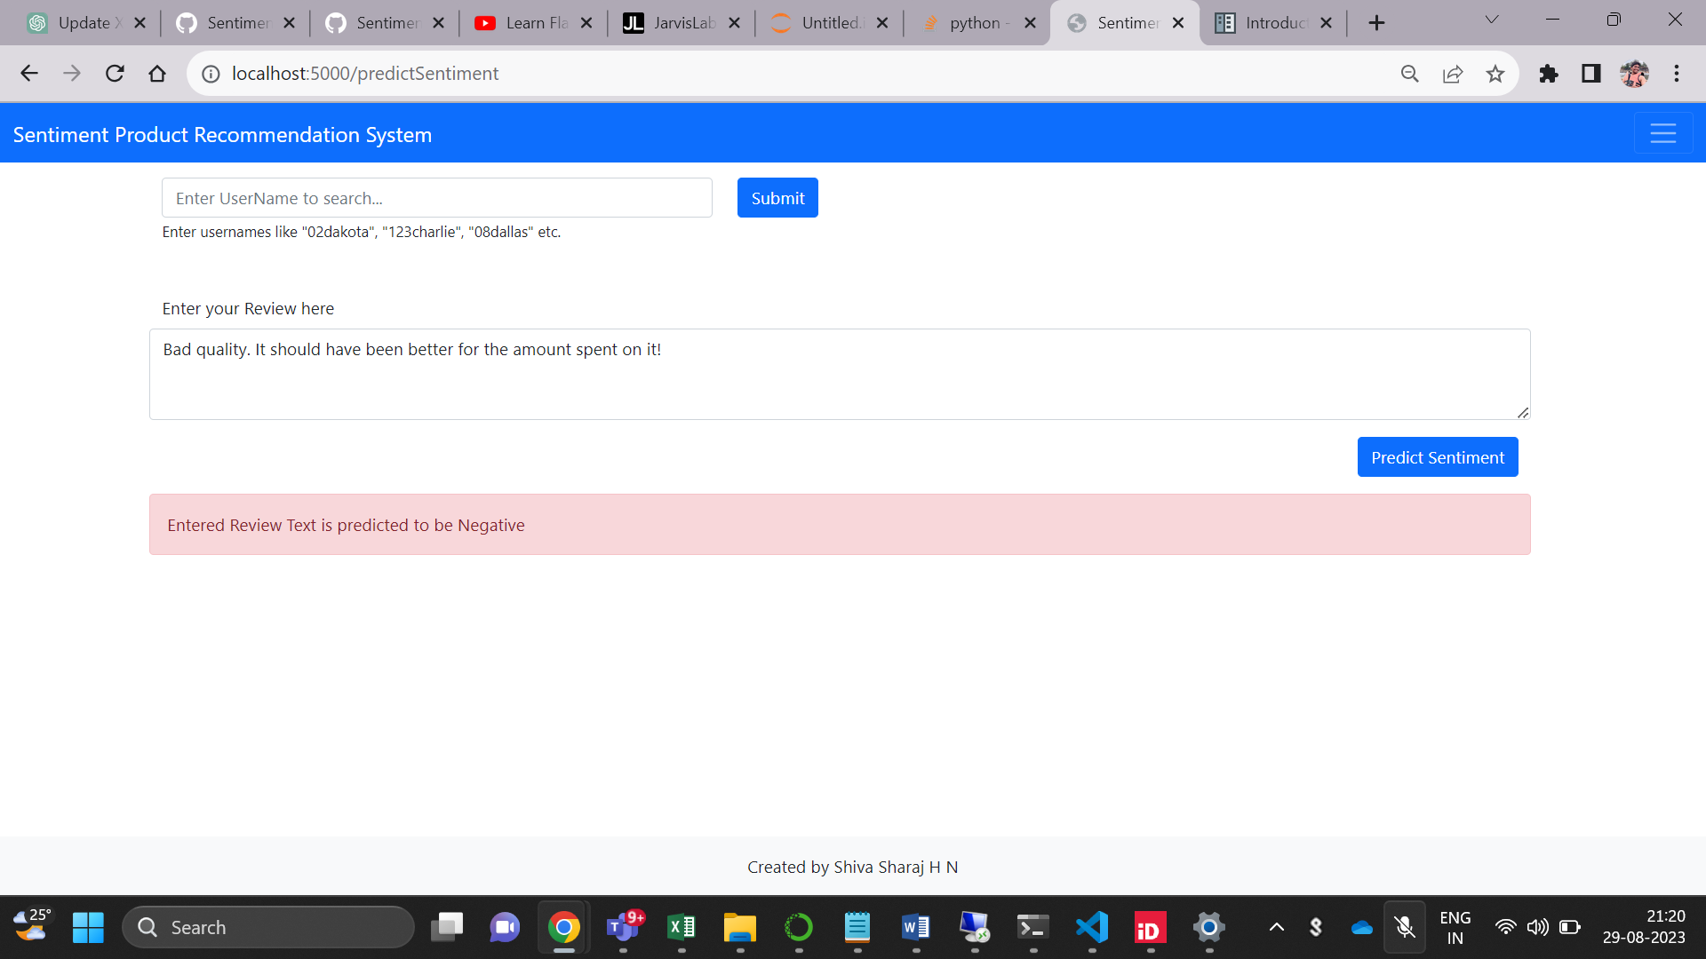

Model was able to predict the sentiment even if the spelling of packaging was wrong.

